**SRIWIJAYA INDONESIA**

# INVOICE

## # 1

Bill To:

**SMKN 5 BATAM**

Date:

Oct 28, 2021

Item

Amount

Quantity Rate

**Ikat Pinggang** 1400 IDR 42,500.00 IDR 59,500,000.00

**Balance Due: IDR 59,500,000.00**

Subtotal: Tax (0%):

Total:

|  |
| --- |
| Mustajib  (Bagian Pemasaran) |

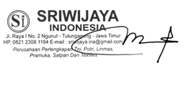

IDR 59,500,000.00

IDR 0.00

IDR 59,500,000.00

**KERAJINAN KULIT "AVIN"**

**Balance Due: IDR 335,335,000.00**

# INVOICE

## # 2

Bill To:

**SMKN 5 BATAM**

Date:

Oct 28, 2021

|  |  |  |  |
| --- | --- | --- | --- |
| Item | Quantity | Rate | Amount |
| **Sepatu PDH Putra** | 1050 | IDR 245,000.00 | IDR 257,250,000.00 |
| **Sepatu PDH Putri** | 322 | IDR 242,500.00 | IDR 78,085,000.00 |

Subtotal: Tax (0%):

Total:

|  |
| --- |
| Mustajib  (Bagian Pemasaran) |

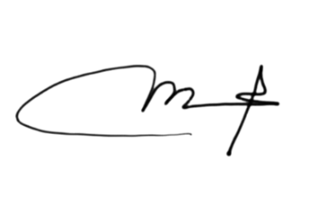IDR 335,335,000.00

IDR 0.00

IDR 335,335,000.00

**ZEIDAN PROJECT WEAR**

**Balance Due: IDR 284,850,000.00**

# INVOICE

## # 3

Bill To:

**SMKN 5 BATAM**

Date:

Oct 28, 2021

|  |  |  |  |
| --- | --- | --- | --- |
| Item | Quantity | Rate | Amount |
| **Baju dan Celana Pramuka Putra** | 1046 | IDR 225,000.00 | IDR 235,350,000.00 |
| **Baju dan Rok Pramuka Putri** | 220 | IDR 225,000.00 | IDR 49,500,000.00 |

Subtotal: Tax (0%):

Total:

|  |
| --- |
| Mustajib  (Bagian Pemasaran) |

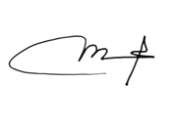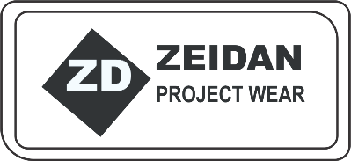IDR 284,850,000.00

IDR 0.00

IDR 284,850,000.00

**A-GRINA COLLECTION**

**Balance Due: IDR 300,080,000.00**

# INVOICE

## # 4

Bill To:

**SMKN 5 BATAM**

Date:

Oct 28, 2021

|  |  |  |  |
| --- | --- | --- | --- |
| Item | Quantity | Rate | Amount |
| **Seragam Kaos dan Traning Olahraga Putra** | 1043 | IDR 220,000.00 | IDR 229,460,000.00 |
| **Seragam Kaos dan Traning Olahraga Putra** | 321 | IDR 220,000.00 | IDR 70,620,000.00 |

Subtotal: Tax (0%):

Total:

|  |
| --- |
| Mustajib  (Bagian Pemasaran) |

****IDR 300,080,000.00

IDR 0.00

IDR 300,080,000.00